# Que.1) Write steps for peer-to-peer connection in cisco packet tracer.

Ans - A peer-to-peer (P2P) network is a simple network where two computers (hosts) are directly connected to each other for communication without a central device like a switch or router. Step 1 - Click on the "End Devices" category (bottom-left). Select "PC-PT" and place two PCs (e.g., PC0 and PC1) on the workspace.

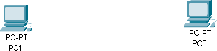

Step 2 - Click on the "Connections" category (lightning bolt icon). Select "Copper Cross-over"

cable. Click on PC0, select "FastEthernet0", Click on PC1, select "FastEthernet0".

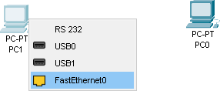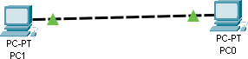

Step 3 - Click on PC0, go to "Desktop" > "IP Configuration". Assign IP Address that follows subnet masking. Close PC0 configuration. Click on PC1, go to "Desktop" > "IP Configuration, assign IP Address then close PC1 configuration.

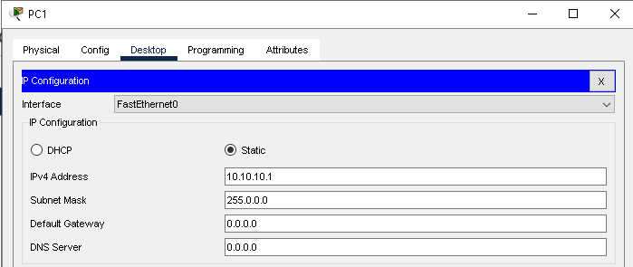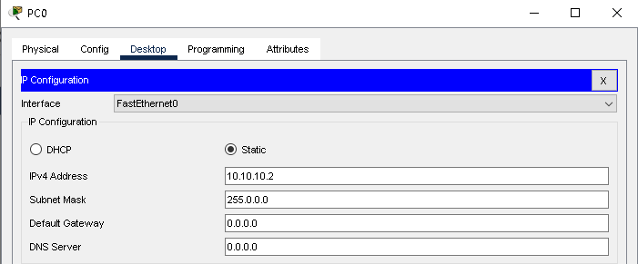

Step 4 - Verify connection using Simple PDU (Packet Testing)

1. Click on the "Add Simple PDU" tool (envelope icon).
2. Click on PC0, then PC1.
3. If the connection is successful, a green checkmark will appear.

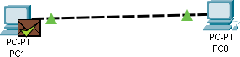

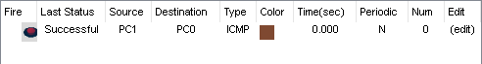

# Que.2) Establish a star topology using hub with 5 devices.

Ans - A star topology is a network configuration where all devices are connected to a central hub or switch. Following are the steps to establish star topology:

Step 1 - Click on "End Devices" (bottom-left menu). Select "PC-PT" and place 5 PCs (e.g., PC0, PC1, PC2, PC3, PC4) on the workspace.

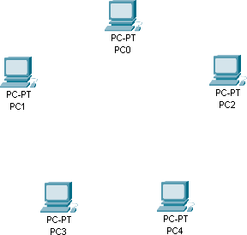

Step 2 - Click on "Network Devices" > "Hubs". Choose a hub (e.g., Generic Hub) and place it in the center.

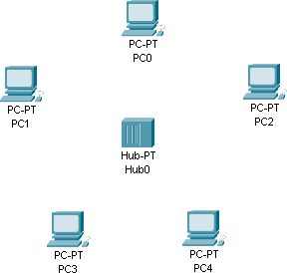

Step 3 - Click on the "Connections" tab (lightning bolt icon). Select "Copper Straight-Through" cable. Click on PC0, select "FastEthernet0", then click on the hub and select any available port (e.g., Port 1). Repeat this for PC1, PC2, PC3, and PC4, connecting each to the hub on different ports.

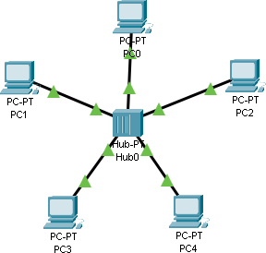

Step 4 - Click on PC0, go to "Desktop" > "IP Configuration", and assign IP Address Repeat for all PCs.

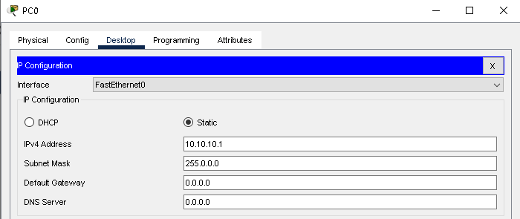

Step 5 - Verify network connectivity using Ping command. Click on PC0, open Command Prompt

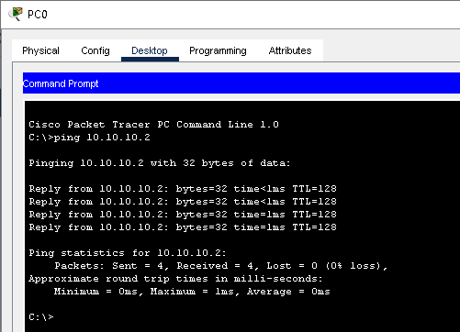(CMD). run ping command with other PC IP Address.

Using PDU:

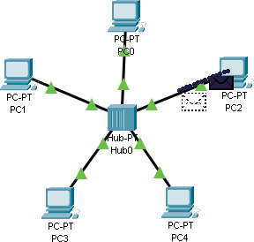 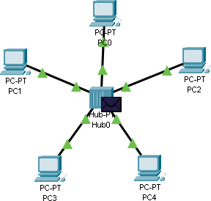 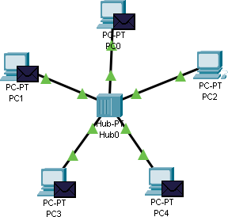

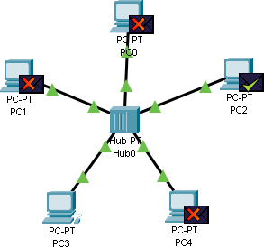

Conclusion - The star topology is a widely used network architecture where all devices are connected to a central hub or switch. This topology offers high reliability, as a failure in one device does not affect the rest of the network. However, the central hub or switch acts as a single point of failure, meaning if it fails, the entire network goes down.